Course Curriculum (for Session 2021-22)

**B.Tech. (Computer Science & Engineering)**

BCSC1005: COMPUTER ORGANIZATION

**Objective:** *This course aims to introducing the concept of computer organization. In particular, it focuses on basic hardware architectural issues that affect the nature and performance of software.*

# Credits: 04

**Semester III**

**L T P: 3 1 0**

|  |  |  |
| --- | --- | --- |
| **Module**  **No.** | **Content** | **Teaching**  **Hours** |
| **I** | **Introduction:** Basic organization of the computer and Block level description of the functional units, Number representation; 1’s and 2’s Complement, Integer Representation, Arithmetic Addition & Subtraction with overflow. fixed and floating-point number representation, IEEE standard floating point representation. Introduction to Combinational Circuit- half adder, full adder, binary adder/subtractor, carry look ahead adders. Multiplexer and De-multiplexer, Register, bus and memory transfer,  **Central Processing Unit**: Addition and subtraction of signed numbers, Multiplication: Signed operand multiplication, Booths algorithm.  Processor organization, general registers organization, stack organization, Three, Two, One & Zero address instruction. Addressing modes, Micro-operations (Arithmetic, Logical & Shift) and its applications. | 20 |
| **II** | **Multiprogramming and Multiprocessing**; Flynn’s classification, Introduction to pipelined operation. Instruction types, formats, Instruction cycles.  **Control Unit:** Execution of a complete instruction. Hardwired and micro programmed control unit. Unconditional and Conditional branching. Microinstruction with next address field, pre-fetching microinstructions, Concept of horizontal and vertical microprogramming.  **Memory:** Basic concept of Memory and its hierarchy, RAM memories, 2D, 2 & 1/2D memory organization. ROM memories. Cache memories: concept and design issues, performance, address mapping and replacement. Virtual memory: concept and implementation.  **Input/Output**: Peripheral devices, I/O interface, I/O ports, Interrupts: interrupt hardware, types of interrupts and exceptions. Buses, bus architecture, types of buses and bus arbitration. Modes of Data Transfer: Programmed I/O, interrupt initiated I/O and Direct Memory Access., I/O channels and processors. Standard communication interfaces. | 20 |

**Text Books:**



**Reference Books:**

rd Edition, PHI.

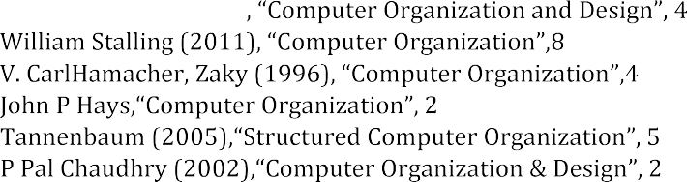D.W. Patterson (2008) th**Edition**, Elsevier Publication.

th Edition, PHI

th International Edition, TMH.

nd Edition, TMH.

thEdition, PHI.

ndEdition, PHI.

**Outcome:** After completion of the course, the student will be able to: Understand the organization of the modern computer system hardware.

Analyze the performance of component, able to calculate the effective address of different operands, arithmetic operations of positive and negative numbers.

Understand the Basic hardware architectural issues that affect the nature and performance of software.

DEPARTMENT OF COMPUTER ENGINEERING & APPLICATIONS, **Institute of Engineering & Technology 44**